**MKTG 1205 Week 9**

Activity 1: Sales Promotion

**Task:**

Propose supermarket/ shopping mall sales promotion tools to help the seller/ product in both **short-term sales** and **long-term brand preference** with its target segments. What benefit will you give to your customers to secure positive outcomes.

**Product Information:** 73,000₫ 1 liter/carton and 35,000₫ 260ml/bottle

In the heart of the Mekong Delta, **Le Fruit** selects the most delicious and freshest fruits from local growers. For the past 15 years the brand has carefully produced farm fresh juices and jams from locally sourced fruits. Never do we import fruit puree from far-flung countries. Following a rigorous quality check, only the premium fruits collected in local farms are immediately squeezed, crushed, blended or simmered. Nothing artificial is added. Never from concentrate. Additive free. GMO free. What you find in our juices, jams and purées comes only from the fruits. And all the natural fibers, vitamins and nutrients of the fresh fruits are kept intact.

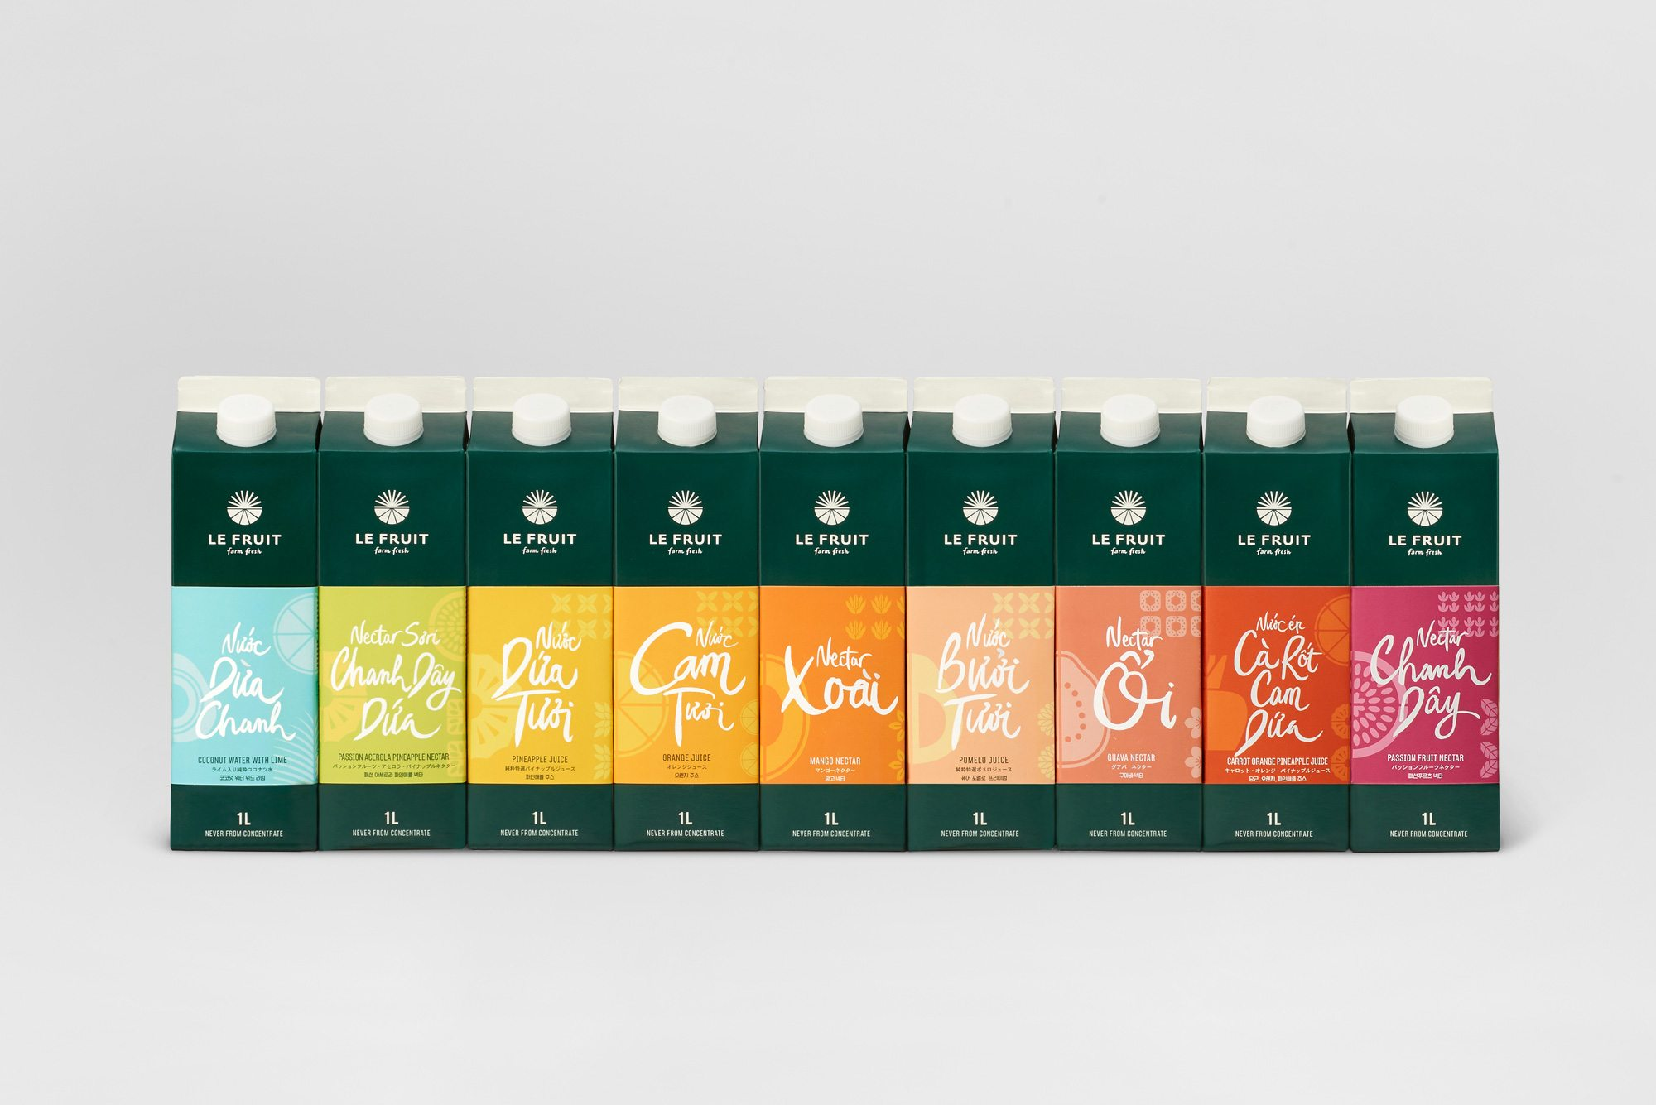

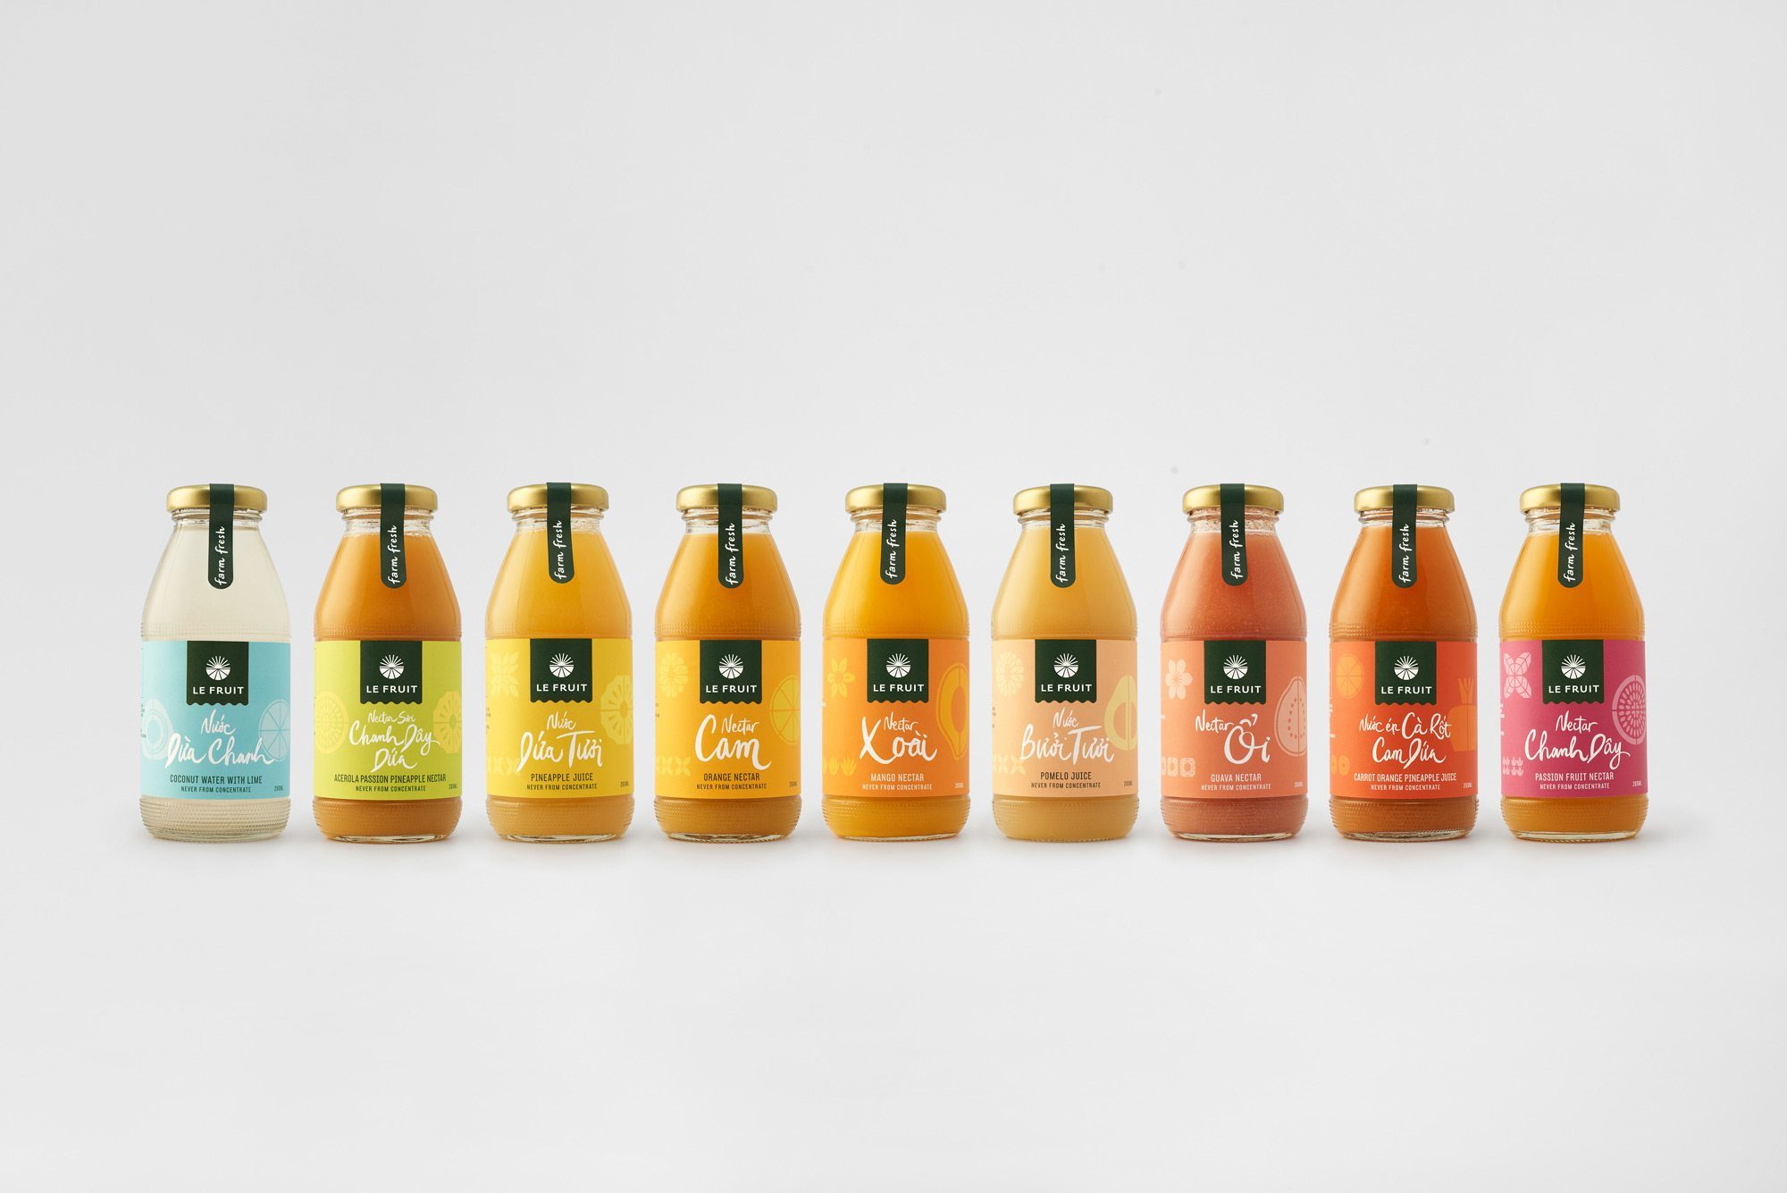­­

|  |  |  |  |  |  |  |
| --- | --- | --- | --- | --- | --- | --- |
| **Segment** | **Profile** | **Needs** | **Market Share**  **%** | **Type Sales Promotion** | **Period of Promotion** | **Price/ Value Benefit to Customer** |
| We are family | Families with young children. Head of the family is 30 years up, low to middle spending, educated and is working rank and file or middle management job. | Physiological and safety needs. |  |  |  |  |
| Just the two of us | Married or co-habiting adults aged 24 years up, middle to high spending, educated, first time job holders or start-up entrepreneurs. | Love/belonging and self-actualization needs. |  |  |  |  |
| Crazy Cat Lady | Senior citizens, retired, living with family or by themselves with pets, low to middle spending, dependent on family’s/ government pension. | Physiological, safety and love/belonging needs. |  |  |  |  |
| #yolo | Young Adults, studying, living with parents or with guardians (not originally from Saigon), middle to low spending, may have a part-time job to supplement family support. | Esteem and self-actualization needs. | ­ |  |  |  |